
COMPUTER VISION
LAB MANUAL — INSTRUCTOR ANSWER KEY
Fundamentals of Computer Imaging
READ | TRANSFORM | ANALYZE | PRACTICE
Fall 2026 – Assessment 2
Course Title | Computer Vision | Credit Hours | 3(2,1)
Course Instructor/s | Muhammad Awais Shoukat | Program Name | BS-AI
Topic | Fundamentals of Computer Imaging | Max Marks | 10
Student's Name | Arooj Komal | Reg. No. | 23-NTU-CS-1140
Assessment Focus | Image processing revision + practical programming | Submission | .ipynb + screenshots
How to use this manual
CONCEPT  Short theory you need before coding. | WORKED EXAMPLE  Complete code — type it, run it, study it. | FILL THE GAP  Code with missing parts. Replace every ______ . | GRADED TASK  The assessment question you submit.

By the end of this lab you will be able to…
- Apply morphological operations (erosion, dilation, opening, closing, gradient) to clean and outline shapes.
- Segment regions using thresholding (binary, inverse, Otsu) and combine masks with arithmetic.
- Detect round objects with contour circularity and with the Hough Circle Transform.
- Detect objects by colour in HSV space and draw labelled results.

Morphological Operations
Grow, shrink, clean and outline shapes with a small structuring element (kernel).

Concept
A kernel is a small matrix (e.g. np.ones((5,5), np.uint8)) that slides over a binary image. A bigger kernel means a stronger effect.

Operation | OpenCV call | What it does
Erosion | cv2.erode(img, k) | Shrinks white regions, removes thin noise.
Dilation | cv2.dilate(img, k) | Grows white regions, fills small gaps.
Opening | MORPH_OPEN | Erosion → dilation. Removes small white specks.
Closing | MORPH_CLOSE | Dilation → erosion. Fills small black holes.
Gradient | MORPH_GRADIENT | Dilation − erosion. Gives the outline of a shape.

Compare all operations on one shape
This example builds its own test image, so it runs without any file.
1 img = np.zeros((200, 200), np.uint8)
2 cv2.rectangle(img, (50, 50), (150, 150), 255, -1) # white square
3 cv2.circle(img, (100, 100), 30, 0, -1) # black hole in the middle
4
5 kernel = np.ones((5, 5), np.uint8)
6 erosion = cv2.erode(img, kernel, iterations=1)
7 dilation = cv2.dilate(img, kernel, iterations=1)
8 opening = cv2.morphologyEx(img, cv2.MORPH_OPEN, kernel)
9 closing = cv2.morphologyEx(img, cv2.MORPH_CLOSE, kernel)
10 gradient = cv2.morphologyEx(img, cv2.MORPH_GRADIENT, kernel)
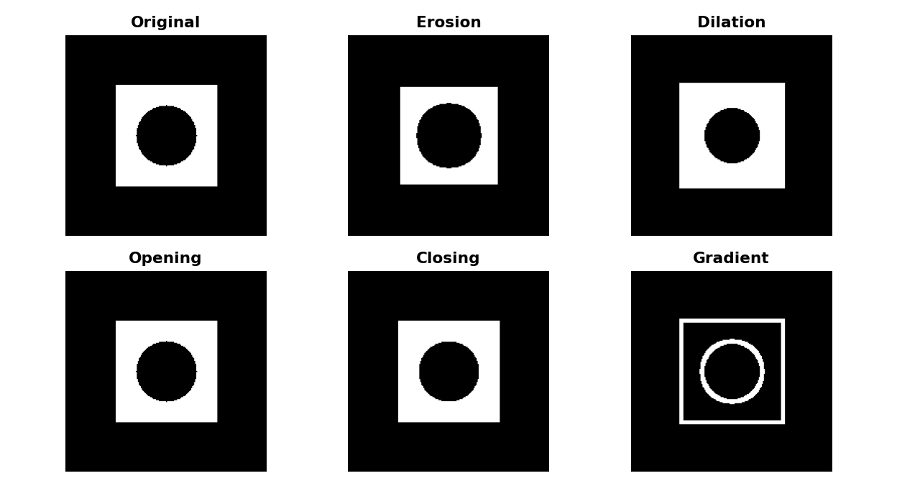

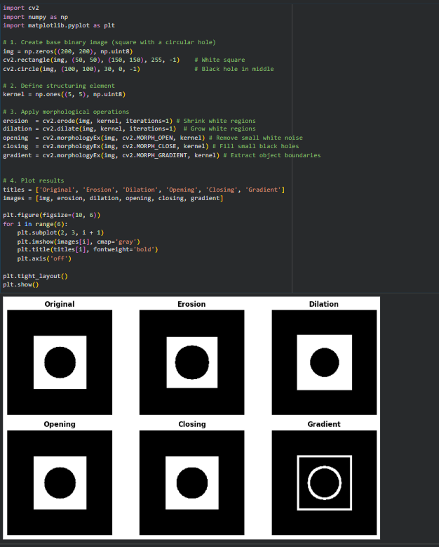
Expected output of Worked Example 1.1
Extract the liquid from the bottles
Pipeline: whole bottle mask → bright empty-part mask → subtract → clean. Hint: find good thresholds by printing pixel values, e.g. print(gray[120, 60]), or by looking at the histogram from 0.3.
1 img = cv2.imread('bottles.png')
2 gray = cv2.cvtColor(img, cv2.COLOR_BGR2GRAY)
3
4 # 1) liquid + empty part of every bottle becomes white
5 _, liquid_white = cv2.threshold(gray, 50 , 255, cv2.THRESH_BINARY)
6
7 # 2) only the very bright, empty part becomes white
8 _, liquid_black = cv2.threshold(gray, 200 , 255, cv2.THRESH_BINARY)
9
10 # 3) remove the empty part -> liquid only (still noisy)
11 liquid_noise = cv2. subtract (liquid_white, liquid_black)
12
13 # 4) clean: opening removes specks, closing fills small holes
14 kernel = np.ones((5, 5), np.uint8)
15 pure = cv2.morphologyEx(liquid_noise, cv2. MORPH_OPEN , kernel)
16 pure = cv2.morphologyEx(pure, cv2. MORPH_CLOSE , kernel)

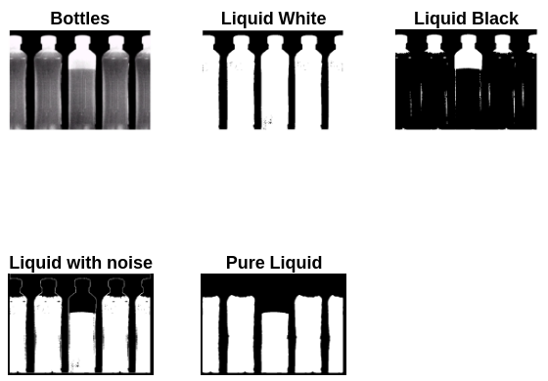

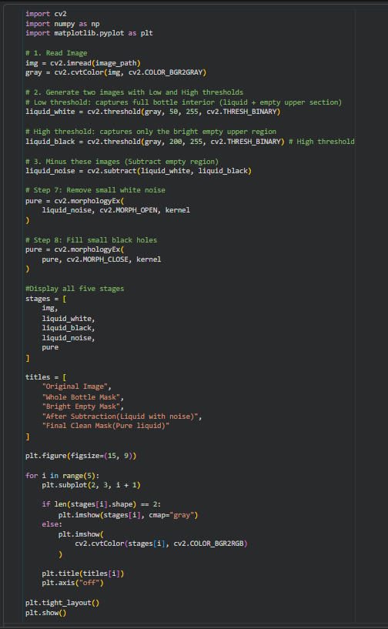
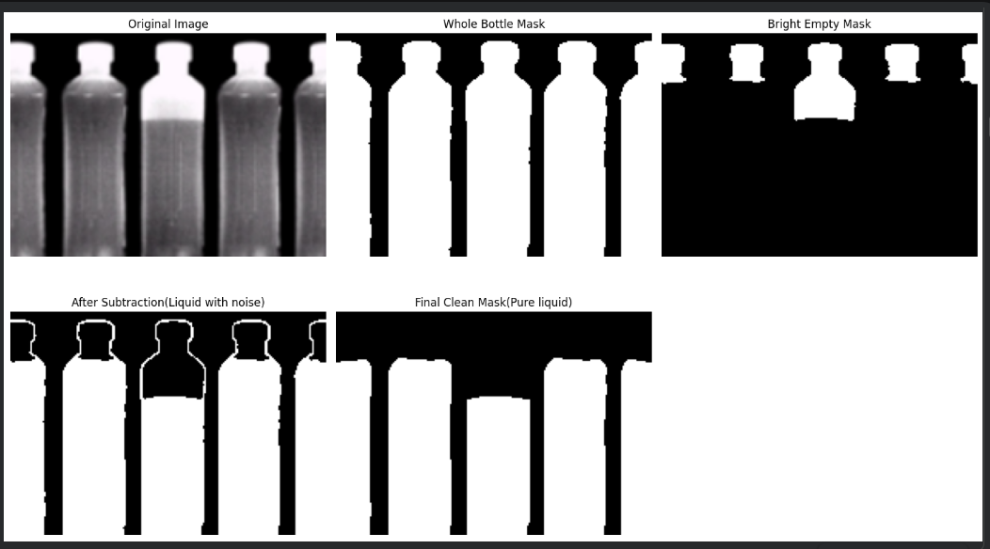
Graded Task — Question 2 (3 marks)
Extract the liquid from the picture of bottles. Your notebook must reproduce all five stages shown above.
- Explain in 2–3 lines how you chose each threshold value.

Low Threshold (50): Selected just above the dark background intensity to eliminate outside noise and segment the entire internal chamber of the bottle (both liquid and empty regions) into a unified foreground mask.
•High Threshold (200): Selected to isolate only the brightest, high-intensity reflections characteristic of the transparent, empty upper section.
Selection Strategy: The difference between these two cut-offs allows clean mathematical subtraction, effectively nullifying the bright empty space while preserving the intermediate-intensity liquid volume

- print the fill level of each bottle as a percentage.
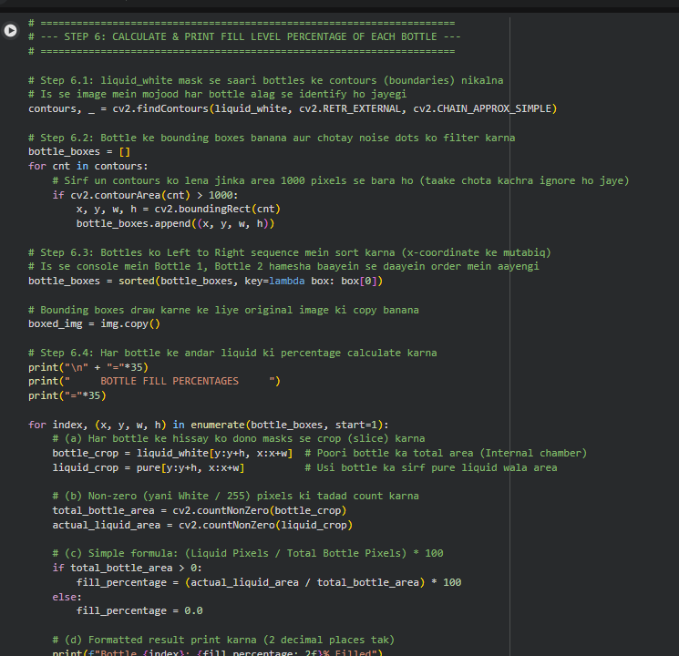
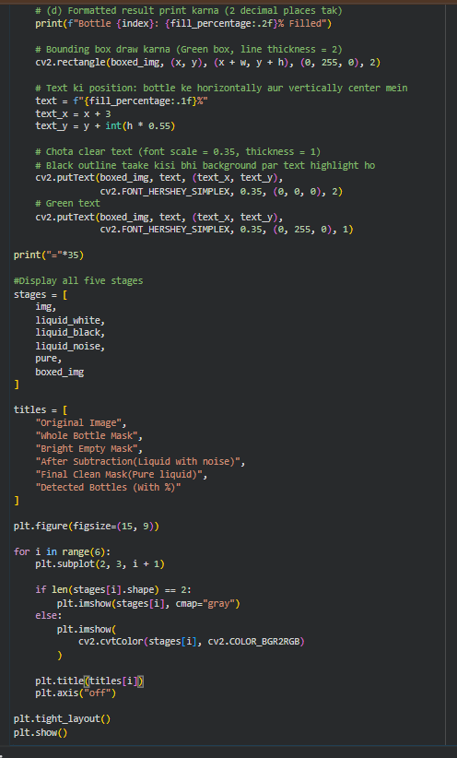
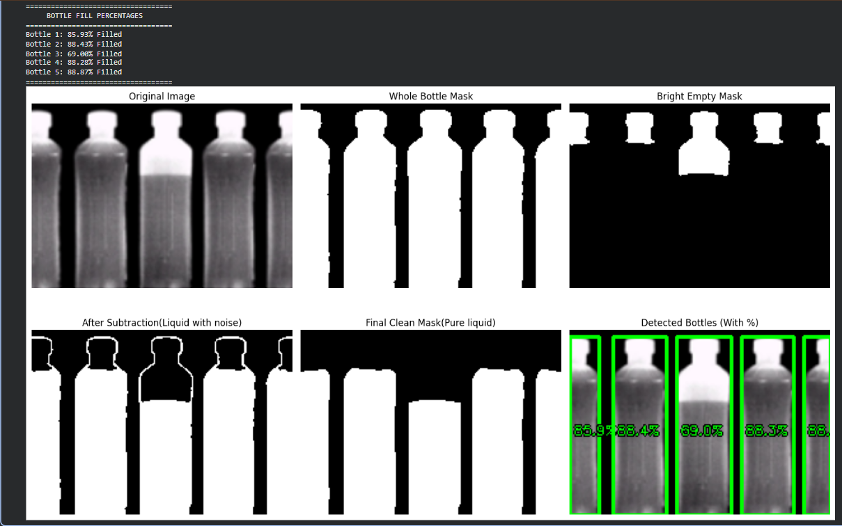

Detecting Round Shapes
Find contours, measure how "circle-like" each one is, and mark the round ones.

Concept — Circularity
Circularity = 4π × Area / Perimeter². It equals 1.0 for a perfect circle and gets smaller for any other shape.

Shape | Circularity | Round?
Circle | ≈ 0.90 – 1.00 | Yes
Square | ≈ 0.785 | No
Equilateral triangle | ≈ 0.60 | No

Classify drawn shapes by circularity
1 canvas = np.zeros((300, 600, 3), np.uint8)
2 cv2.circle(canvas, (100, 150), 70, (255, 255, 255), -1)
3 cv2.rectangle(canvas, (220, 80), (360, 220), (255, 255, 255), -1)
4 pts = np.array([[500, 80], [430, 220], [570, 220]], np.int32)
5 cv2.fillPoly(canvas, [pts], (255, 255, 255))
6
7 gray = cv2.cvtColor(canvas, cv2.COLOR_BGR2GRAY)
8 _, thresh = cv2.threshold(gray, 0, 255, cv2.THRESH_BINARY + cv2.THRESH_OTSU)
9 contours, _ = cv2.findContours(thresh, cv2.RETR_EXTERNAL, cv2.CHAIN_APPROX_SIMPLE)
10
11 for c in contours:
12 area = cv2.contourArea(c)
13 perimeter = cv2.arcLength(c, True)
14 circularity = 4 * np.pi * area / (perimeter ** 2)
15 x, y, w, h = cv2.boundingRect(c)
16 is_round = circularity > 0.8
17 color = (0, 255, 0) if is_round else (0, 0, 255) # green / red (BGR)
18 label = 'CIRCLE' if is_round else 'not circle'
19 cv2.drawContours(canvas, [c], -1, color, 3)
20 cv2.putText(canvas, f'{label} {circularity:.2f}', (x, y - 10),
21 cv2.FONT_HERSHEY_SIMPLEX, 0.6, color, 2)

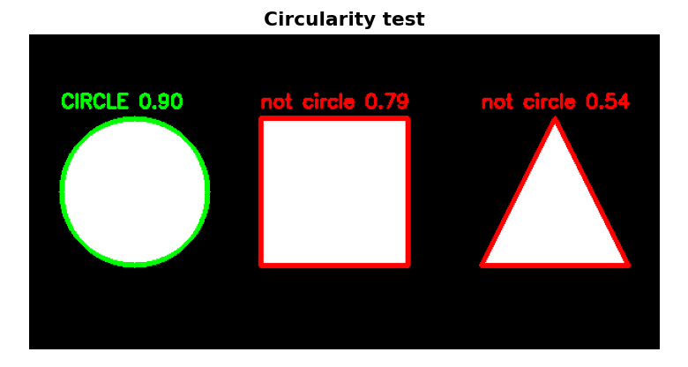

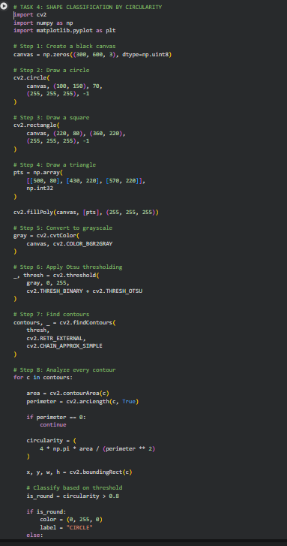
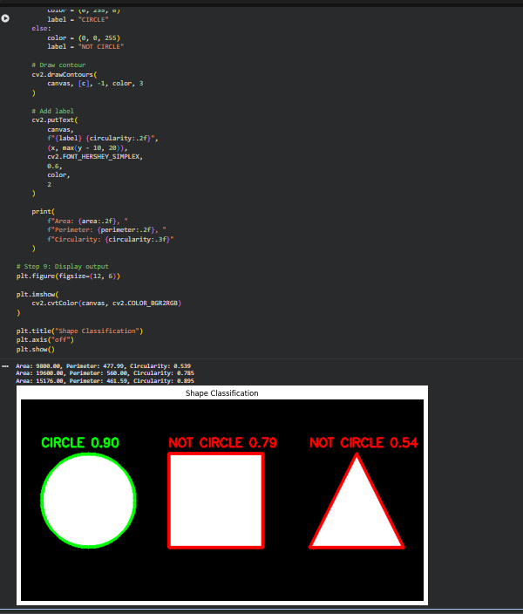
Expected output of Worked Example 3.1

Separate touching apples and label them


